

YEAR 11 SEMESTER ONE 2005

HUMAN BIOLOGY EXAMINATION

THIS CONTAINS
SECTION A
AND
SECTION C

TIME ALLOWED FOR THIS PAPER

Reading Time: 10 minutes
Working Time: 150 minutes

Section A:
Multiple Choice – 40 Questions – 40%
Answer the multiple choice questions by CROSSING out the letter of your choice on the answer sheet provided.

Section B:
Short Answers – Questions – 40%
Answer the questions in the spaces provided in the booklet. Answers are to be in BLUE or BLACK biro.

Section C:
Extended Answers – 2 Questions – 20%
ALL PARTS OF QUESTIONS 1 or 2 and ALL PARTS OF QUESTIONS 3 or4
Write the answer on the lined paper provided.

YEAR 11 HUMAN BIOLOGY EXAM

PART 1 MULTIPLE CHOICE – 40 Marks

Choose the most correct answer to each question and mark your answer on the separate multiple choice answer sheet. If you change an answer, make sure the old one choice is crossed out and the new choice is clearly marked.

- The series of interconnecting canals that transport fluid through a cell are called:
- Endoplasmic Reticulum
- Centrioles
- Golgi bodies
- Mitochondria.

- In passing from the lungs to the kidneys, the blood would have to pass through the:
- pulmonary artery, tricuspid valve and aorta
- pulmonary vein, bicuspid valse and aorta
- pulmonary artery, bicuspid valve and aorta
- bicuspid valve, aorta and renal vein.

- Erythrocytes differ from leucocytes in that they:
- are less numerous
- are biconvex in shape
- possess a cell wall
- do not have a nucleus.

- Severe haemorrhage is dangerous primarily because:
- there is a danger of entry of pathogens through the wound
- drop in blood volume
- red blood cells are irreplaceably lost
- air bubbles can enter the blood stream.

- Intercellular fluid:
- makes up 50% of the body’s weight
- contains a large amount of blood protein
- is present in the vacuoles of cells
- carries materials between the cells and the blood.

- The following four statements are about the events occurring during different phases of the cardiac cycle.
- Atrial systole is the phase of active contraction of the atria.
- Ventricular diastole is the period during which filling of the ventricles occurs.
- Blood enters the right atrium from the pulmonary veins during atrial diastole.
- Blood enters the aorta and the pulmonary arteries during ventricular systole.

Which group of the above statements is CORRECT?

- A and B only
- A, B and D only
- B, C and D only
- All are correct.

- Which of the following comparisons between the blood and lymphatic system is NOT correct?
 | BLOOD SYSTEM | LYMPHATIC SYSTEM
A | The flow is away from the heart | The flow is towards the heart
B | The system leaks fluid into the tissues | The system collects up the leaked fluid
C | Valves are present in some of the vessels | Valves are also present
D | Contains red blood cells | Contains no red blood cells

- The pulmonary artery carries:
- deoxygenated blood from the right atrium to the lungs
- oxygenated blood from the lungs to the left ventricle
- deoxygenated blood from the right ventricle to the lungs
- oxygenated blood from the lungs to the left atrium.

- A double-walled membrane surrounding the heart is called the:
- periosteum
- perilymph
- pericardium
- peritoneum.

- Compared with arteries, veins:
- have thicker walls
- contain blood at a lower pressure
- are capable of contraction
- convey blood away from the heart.

- The ventricular wall is thicker than the atrial wall so that it can:
- exert a greater force when pumping blood
- receive more blood
- oxygenate the blood faster
- control the volume of blood pumped out.

- Four microscopes were set up in the laboratory as follows:
MICROSCOPE | OBJECTIVE | OCULAR
A | 10 X | 5 X
B | 20 X | 10 X
C | 40 X | 5 X
D | 40 X | 10 X

When looking at a slide of human tissue, with which microscope would you expect to observe the fewest cells?
- A
- B
- C
- D

- The organelles in a cell which are responsible respectively for protein synthesis, energy production and secretion are:
- ribosomes, golgi bodies, endoplasmic reticulum
- golgi bodies, ribosomes, mitochondria
- mitochondria, nucleus, cell membrane
- ribosomes, mitochondria and golgi bodies.

- The diagram below illustrates some of the many events in mitosis.

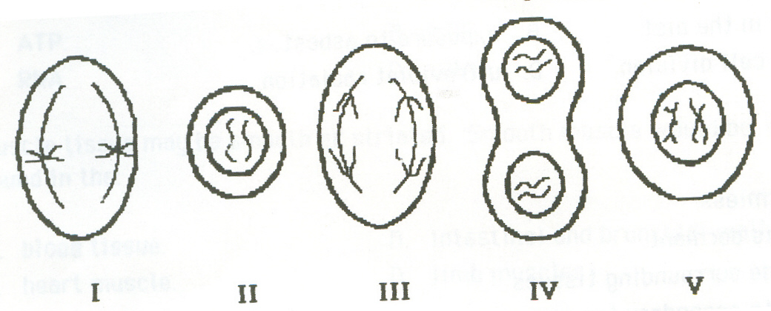

The correct sequence of these events is as follows:
- IV, II, III, V, I
- IV, III, V, I, II
- I, V, III, II, IV
- D V, I, III, IV, II

- Smooth muscle tissue:
- forms the walls of the heart
- is in the walls of veins
- is attached to the skeleton
- is consciously controlled.

- A benign tumour:
- is always harmless
- is one which is dormant
- does not invade surrounding tissues
- can give rise to secondary tumours.

- Energy produced by cell respiration is stored in the form of:
- ribonucleic acid
- concentrated carbohydrates
- adenosine triphosphate
- deoxyribonucleic acid

- The body can be sequentially divided into units of decreasing size. From the largest to the smallest units, the correct sequence is:
- cells, organelles, tissues, organs, systems
- systems, organs, tissues, cells, organelles
- cells, tissues, organelles, organs, systems
- systems, organs, organelles, tissues, cells

- Protective padding around the kidney and behind the eye is composed of:
- Cartilage
- white fibrous tissue
- adipose tissue
- yellow elastic tissue

- Which of the following is the best definition of osmosis?
- Movement of molecules from regions of high concentration to regions of low concentration
- movement of molecules from regions of low concentration to regions of high concentration
- net movement of solvent molecules across a differentially permeable membrane
- random movement of molecules or ions in solutions

- Binocular (stereoscopic) vision has enabled the higher primates to:
- judge distances successfully
- develop two- dimensional vision
- see in colour
- extend their field of vision

- One adaptation for the brachiation method of locomotion is:
- opposable thumb and short arms
- elongated thumb and long arms
- elongated digits and long arms
- opposable thumb and short legs

- Which of the following is an INCORRECT statement of characteristics shared by all primates?
- Nails and friction ridges
- Opposability of the first digit but generally unspecialized limb structure
- Rhythmical sexual cycle
- Increased field of vision

- Which of the following would not be included in the primate group “ANTHROPOID”?
- baboon
- gibbon
- lemur
- gorilla

- A primate which has a prehensile tail, brachiates as its main method of locomotion, has an arboreal habitat and lives in South America would belong to which group ?
- Prosimians
- New World Monkeys
- Old World Monkeys
- Lesser Apes

- Identification of a skull as human rather than ape would be best done by observing
- the size of the teeth
- the position of the foramen magnum
- the eye socket
- the width of the pelvis

- Which of the following lists states the major levels of taxonomic classification in order of decreasing diversity within each level?
- Species, genus, order, class, family.
- Class, order, family, genus, species.
- Order, class, species, family, genus.
- Class, order, genus, family, species.

- The primate pictured below belongs to the group of Primates known as:
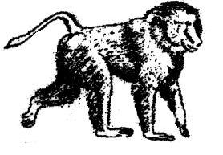

- Hominoidea.
- Tupaioidea.
- Ceboidea.
- Cercopithecoidea.

- Some species of primates are territorial. Which one of the following species uses scent to mark its territory?
- Orangutans
- Lemurs
- Chimpanzees
- Baboons

- Of the hands shown below, which is most probably a member of the Prosimians?
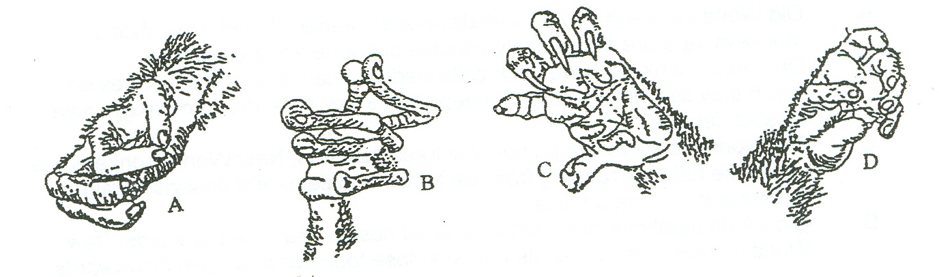

- Hand A
- Hand B
- Hand C
- Hand D
- Which of the letters below on the diagram represent a hinge joint?
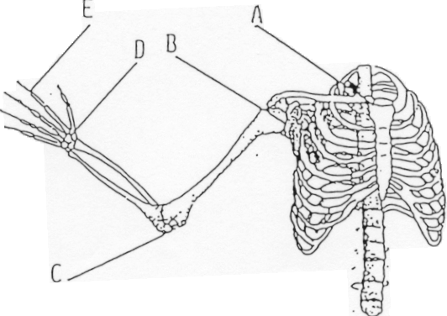

- A
- B
- C
- D

- A patient was diagnosed with the following symptoms: soft bones especially the legs which continued to bow when walking. This person would most likely be suffering from?
- Spina bifida.
- Rickets.
- Scurvy.
- Lack of iron in diet.

- The diagram below is an example of which type of joint?
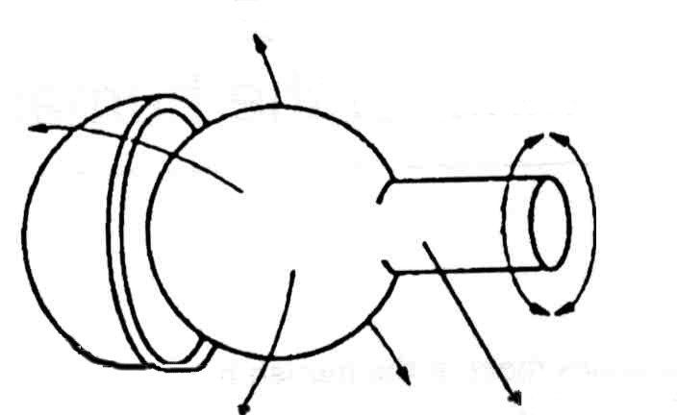

- Ball and socket.
- Pivot.
- Hinge.
- Gliding.

- Give the name of the following joint.
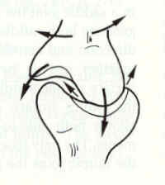

- Hinge joint.
- Ball and Socket joint.
- Gliding Joint.
- Saddle Joint.

- Which of the following diagrams shows a lumbar vertebrae?
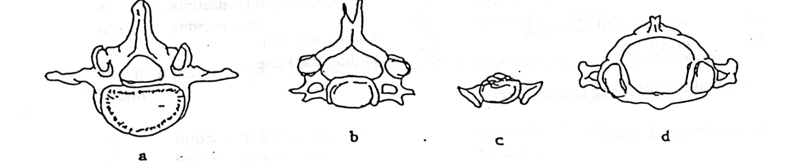

- A
- B
- C
- D

- The axial skeleton consists of which:
- Skull and ribs.
- Skull shoulder girdles and vertebrae.
- Shoulder girdle, pelvic girdle and limbs.
- Pelvic girdle, collar bones and arms.

- In the diagram below, the region of the long bone that is responsible for red blood cell production is:
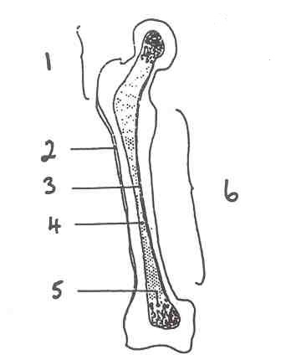

- 4
- 5
- 1
- 6

- Examine the diagram of a muscle fibre below:
A Band

I Band

The A band shown above is made up of
- actin and myosin fibres
- actin and creatine fibres
- myosin fibres only
- actin fibres only

- The muscles involved in extending the limb at the knee joint is the
- gastrocnemius
- tibialis anterior
- rectus femoris
- quadriceps

- Which of the following terms describes a displacement of a joint with the tearing of ligaments, tendons or capsules?
- Sprain
- Fracture
- Strain
- Dislocation

END OF SECTION A

Put a cross ‘X’ next to the most correct answer.
Name:

1 | A | B | C | D |  | 21 | A | B | C | D
2 | A | B | C | D |  | 22 | A | B | C | D
3 | A | B | C | D |  | 23 | A | B | C | D
4 | A | B | C | D |  | 24 | A | B | C | D
5 | A | B | C | D |  | 25 | A | B | C | D
6 | A | B | C | D |  | 26 | A | B | C | D
7 | A | B | C | D |  | 27 | A | B | C | D
8 | A | B | C | D |  | 28 | A | B | C | D
9 | A | B | C | D |  | 29 | A | B | C | D
10 | A | B | C | D |  | 30 | A | B | C | D
11 | A | B | C | D |  | 31 | A | B | C | D
12 | A | B | C | D |  | 32 | A | B | C | D
13 | A | B | C | D |  | 33 | A | B | C | D
14 | A | B | C | D |  | 34 | A | B | C | D
15 | A | B | C | D |  | 35 | A | B | C | D
16 | A | B | C | D |  | 36 | A | B | C | D
17 | A | B | C | D |  | 37 | A | B | C | D
18 | A | B | C | D |  | 38 | A | B | C | D
19 | A | B | C | D |  | 39 | A | B | C | D
20 | A | B | C | D |  | 40 | A | B | C | D
YEAR 11 HUMAN BIOLOGY EXAMINATION – SEMESTER 1 2005

SECTION C:
EXTENDED ANSWERS

Answer question 1 or question 2

AND

Answer question 3 or question 4.

Fill in the answers to your essays in this booklet.
Number your questions appropriately.
All answers are to be written in blue or black biro pen.
Diagrams are to be done in pencil with labels.
Spelling and grammar count towards your final mark.
Good luck!!

You are required to answer:

ALL PARTS OF QUESTIONS 1 or 2 AND ALL PARTS OF QUESTIONS 3 or 4

1. (a) Describe an enzyme. [2]
(b) Enzymes have specificity. How is this achieved? [2]
(c) Describe the factors which influence the activity of enzymes. [4]
(d) Distinguish between the three major types of joints on the basis of both structure and function, making sure the various synovial joints are described. Include labelled diagrams where appropriate and provide examples of specific locations and the possible range of movements these joints allow. [12]
OR
2. (a) Discuss in detail, structural adaptations the human skeleton possesses to enable an erect posture and bipedal motion. Include diagrams where appropriate. [6]
(b) Describe the Sliding filament model for muscle contraction. [6]
(c) Once a muscle is stimulated, it requires energy to contract. The energy comes from a chemical reaction. Describe the processes which produce energy for the muscles of a runner in a sprint race and also during an endurance race. [8]
AND
3. (a) Describe the pathway of a red blood cell from when it enters the heart through the vena cava to when it leaves the heart. [4]
(b) Using the terms diastole and systole, describe the action of the heart muscle during the cardiac cycle. [8]
(c) What causes the sounds made during a heart beat?[2]
(d) Relate the structures of arteries, veins and capillaries to their different functions within the circulatory system.[6]
OR
4. (a) Describe the structure of the long bone, both from its internal and external appearance as seen in longitudinal section. Include a fully labelled diagram. [10]
(b) Mitosis ensures that body cells are exact copies of parent cells. Referring to labelled diagrams, explain all the stages of renewal or replacement of cells during this process. [10]

